Connected Quizzing
Connected Quizzing is a required component of this course. With Connected Quizzing, you’ll take assigned quizzes on Casebook Connect that will help you learn the course material and get detailed feedback to help you improve in class.

Step 1: PURCHASING ACCESS

You have two ways to purchase Connected Quizzing:

- Print Book + CQ Bundle Option: Purchase a bundle with a new print textbook for a discounted price. If you prefer the bundle option, please purchase this special ISBN available in the bookstore 9798886141214. Your book will come bundled with a scratch-off sticker inside the front cover (shown below) or as an access card shrink-wrapped to the back cover of your textbook (do not throw this code away). Redeem this access code at www.CasebookConnect.com. If your book does NOT come with a Connected Quizzing access code, you did not purchase the appropriate bundled product, and you will be required to purchase Connected Quizzing separately.

  - Cover and scratch-off inside front cover:
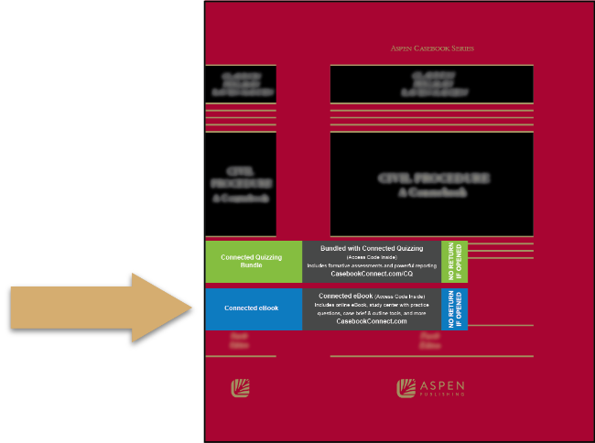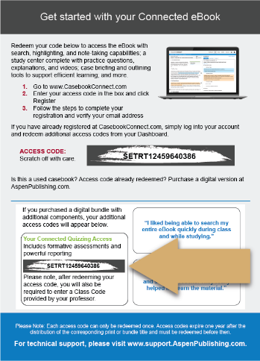

  - Access card:

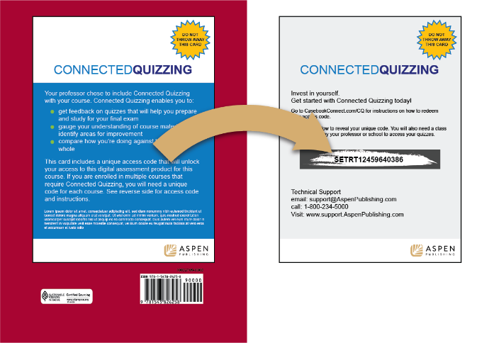

- CQ Only Direct Purchase: If you already purchased your textbook elsewhere, you can also purchase Connected Quizzing separately at www.AspenPublishing.com/CQ. Follow the instructions provided after completing your purchase to access Connected Quizzing on Casebook Connect.

Step 2: CLASS CODE
Once you have successfully purchased access or redeemed your access code, you will see Connected Quizzing on your dashboard when you log into your Casebook Connect account. You will then be prompted to enter a class code to connect with my class and see your assignments.

Enter Class Code: HEMING626470

Helpful Information
Watch a Tutorial Video
Download Quick Start Guide PDF
Request Technical Support
For more information, visit www.CasebookConnect.com/CQ.

